DCM Report

My winning model is model 2, which models the influence of working memory to be top down only. See Figure 1.

The Bayes Factor for model 2 better than model 1 is 2.0102 x 1088 which is very strong. The Bayes Factor for model 2 better than model 3 is 2.4447 x 107 which is also very strong. The Bayes Factor for model 2 better than model 4 is 1.5811, which is weak. Therefore, my best model is model 2, but the confidence for selecting this model over model 4 is very weak.

Figure 1

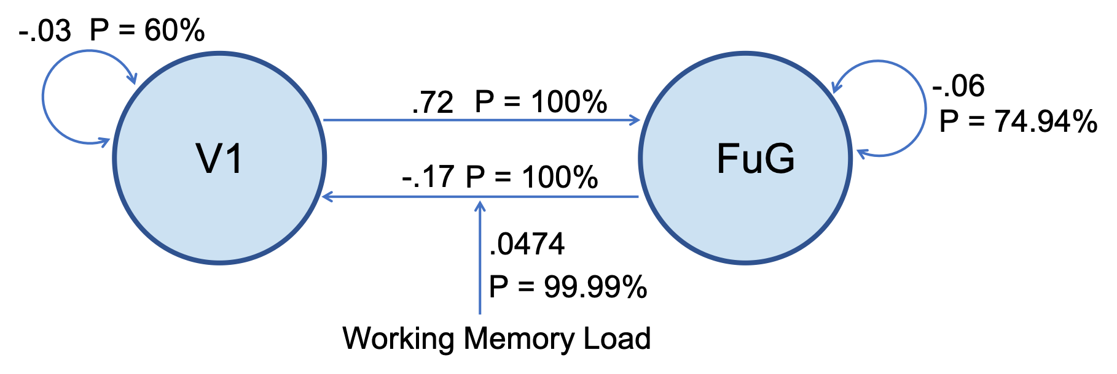

**Model 2: The influence of working memory to be top down only**